**

安全衛生マニュアル

Health and Safety Guide

2024年4月

April 2024

Contents

０．Introduction 1

0.2　Contact Information 1

1.　Environmental Safety Management 2

1.1　 Responsibility-taking System 2

1.2　Safety Patrols and Regular Inspections 2

1.2.1　Safety Patrols 2

1.2.2　Inspections 2

1.3　Safety Education 3

1.3.1　Basic Training 3

1.3.2　Special Training 3

1.3.3　Other workshops and practical training 3

2.　Fire and Disaster Prevention 4

2.1　Confirmations 4

2.1.1　Contact Information 4

2.1.2　Evacuation 5

2.1.3　 Disaster Prevention Equipment 5

2.1.4　Emergency Drills 5

2.1.5　Safety Confirmation in the Event of a Large-Scale Disaster 5

2.2　Disaster Preparedness 6

2.2.1　Security 6

2.2.2　Anti-toppling measures 6

2.2.3　Fire Risk Assessment and Fire Prevention 6

2.3　Emergency Procedures 7

2.3.1　Basics of Emergency Response 7

2.3.2　 Response to Fire 7

2.3.3　Response to Explosions 8

2.3.4　Response to Chemical Leaks 8

2.3.5　Response to Earthquakes 9

2.3.6　Response to Accidents 10

2.3.7　 Automated External Defibrillators (Using AEDs) 10

３．Waste Disposal 11

3.1 Daily-life waste 11

3.2　Laboratory Waste 11

3.3　Special Waste 11

４.　 Precautions in office work 12

4.1　Prevention of Health Problems Caused by Working with Information Equipment 12

4.2　 Health care while telecommuting 12

4.3　Back Pain Prevention 13

5.　Labor Basics for University Members 14

5.1　Faculty 14

5.1.1　 Occupational Accidents 14

5.1.2　 Occupational Accidents under Special Circumstances 14

5.1.3　 Commuting Accidents 14

5.2　Students 14

5.2.1　 Accident Insurance for Students 14

６.　 Health Care and Consultation Services 15

6.1　Health Care 15

6.1.1　Health Examinations 15

6.1.2　Mental Health 15

6.1.3　Consultation Service 15

６.2　Harassment Response 15

6.2.1　Consultation Service 16

7. Specialized Matters to be Observed when Carrying Out Research Activities 16

7.1　 Principles of Safety Management 16

7.2　 Precautions during Experiments 16

7.3　 Management of Chemical Substances 17

7.3.1 Chemicals and High-Pressure Gas Management System (UTCIMS) 17

7.3.2　 Hazardous Substances and Legal Regulations 17

7.3.3　 Precautions for Handling Hazardous Substances 17

7.3.4　 Management Required by Regulations 18

7.4 Radiation Control 20

7.5　 Biosafety 20

7.6　 Equipment Management 21

7.7　Protective Equipment Management 21

7.8　Laboratory Waste 22

8.Education and Research Activities during Field Work 23

8.1 Submission of Health and Safety Management Plan 23

8.2　Use of Drones 23

8.3　Bee Sting Prevention 23

Appendix 24

The School of Science Designated Evacuation SiteMap of AED locations for the School of Science 25

Contact Information in Emergencies 26

# ０．Introduction

0.1　Overview and Objectives

This Safety and Health Manual summarizes the minimum safety requirements that all members of the School of Science must know in order to ensure that all educational and research activities are conducted safely and smoothly in compliance with the Industrial Safety and Health Law, the Fire Service Law, the Poisonous and Deleterious Substances Control Law, and radiation-related laws and regulations. While the basic safety management is described for each member of the team, the responsible persons in each department, laboratory, office, etc. are required to be fully aware of their management responsibilities and actively enhance the safety management system of their teams and organizations.

Faculty members and students who do not conduct experiments should study items 1 through 6, and faculty members and students who conduct experiments should study item 7 in addition to these items, and item 8 if necessary.

## 0.2　Contact Information

The contents of this Guide are offered by the Environment and Safety Management Office, The School of Science, The University of Tokyo (hereinafter known as the ESMO).

**ESMO**

Faculty of Science Bldg. 1, West Area, Room 103

Email : [kankyo.s@gs.mail.u-tokyo.ac.jp](mailto:kankyo.s@gs.mail.u-tokyo.ac.jp)

TEL : 03-5841-8868, ext. 28868

ESMO Website :

<https://jimubu.adm.s.u-tokyo.ac.jp/public/index.php/Esmo> (Japanese only)

Website of the Division for Environment, Health and Safety, UTokyo :

<https://univtokyo.sharepoint.com/sites/EHS_portal>

Details and up-to-date information on health and safety management are available on the websites for the ESMO and the Division for Environment, Health and Safety at the University of Tokyo, and you are duly recommended to refer to these sites.

**[This is a machine translation for your reference. Please note that the translation may not be accurate.]**

# 1.　Environmental Safety Management

## 1.1　 Responsibility-taking System

Figure 1 shows an overview of the environmental safety management system of the UTokyo and the Schools of Science. The UTokyo requires that environmental safety management be carried out in accordance with the following responsibility system: Dean of the Graduate School (responsible for the Graduate School) - Director of the department/facility (responsible for the department) - Responsible person of the laboratory/facility, etc. In particular, the person in charge of each department, laboratory, office, etc. must be fully aware of his/her management responsibilities.

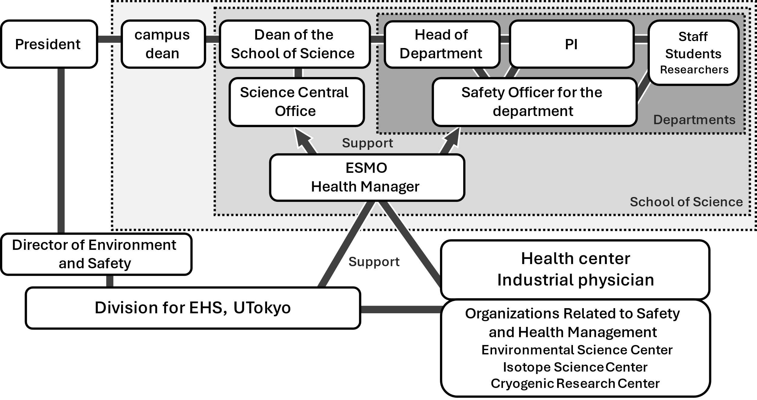In addition, not only faculty members but also students are required to be aware of the importance of safety and health management and compliance with laws and regulations on the same basis as faculty members when conducting research and experimental activities. Please fully understand the responsibility structure and the importance of environmental and safety management before engaging in such activities.

Figure 1 Environmental Safety Management System

## 1.2　Safety Patrols and Regular Inspections

In order to prevent accidents, disasters, and environmental pollution, the industrial physician and health manager will conduct safety patrols, and the laboratory manager will conduct regular inspections. Please make improvements to any items pointed out during the inspection.

### 1.2.1　Safety Patrols

* Patrols by industrial physicians: Once a year, covering all rooms
* Patrol by health manager
* Safety and health patrol by the Dean of the Graduate School: Once a year, the Dean selects a target and conducts the patrol.

### 1.2.2　Inspections

* Daily inspections by laboratory supervisors, etc.
* Equipment and facilities for which notification at the time of installation and periodic self-inspection and inspection are required by law:

Localized ventilation equipment, X-ray equipment, pressurized containers, gas detectors, centrifuges, autoclaves, cranes, etc.

*ESMO conducts inspections for local ventilation equipment and gas detectors.

## 1.3　Safety Education

Various types of safety training are provided to enable members to know where and what hazards are inherent in their research and work, to protect themselves from those hazards, and to take measures to prevent them.

### 1.3.1　Basic Training

All members, including students, part-time fixed-term faculty and staff, are required to take one of the following basic safety training courses at the time of admission to the school, at the time of joining the School of Science, and at the time of any change in the nature of their work.

* New students, new faculty members, new research students, etc.

・Safety seminar held at the guidance for new students in April every year

・Environmental safety basic training provided by the School of Science (e-learning)

* Faculty members who joined in the middle of the school year, etc.

・Safety and health training provided by your laboratory or department/facility

・Environmental safety basic training provided by the School of Science (e-learning)

### 1.3.2　Special Training

　The following members are required to take the necessary training courses.

* Persons who perform work that requires special training stipulated in the Industrial Safety and Health Law (crane operations, crane slinging operations, grinding stone replacement, arc welding, chain sawing, etc.)

・Training to acquire the knowledge and skills required for the work (sponsored by an external organization that conducts legally mandated training)

* Persons who use radiation/radioactive materials (RI) or X-ray generators

・Training for those who use X-ray generators and radiation/radioactive materials (RI) (Organizer: Radiation Management Office, the School of Science)

### 1.3.3　Other workshops and practical training

Please attend the following depending on the handling of your research.

* Environmental safety seminar (hosted by the Research Center for Environmental Safety): When conducting experiments and research
* Safety seminar and high-pressure gas seminar (hosted by: Cryogenic Center)
* Chemicals, etc. (chemicals, UTCIMS, high-pressure gas, lasers) handling seminar (hosted by: Environment and Safety Division)
* Seminar on handling and inspection of equipment, etc. (centrifuges, draft chambers, autoclaves)
* Training sessions on genetically modified organisms, animal experiments, etc. (Organized by Life Science Research Ethics Support Office)

# 2.　Fire and Disaster Prevention

## 2.1　Confirmations

In order to respond appropriately in the event of a disaster, please confirm the following in advance.

### 2.1.1　Contact Information

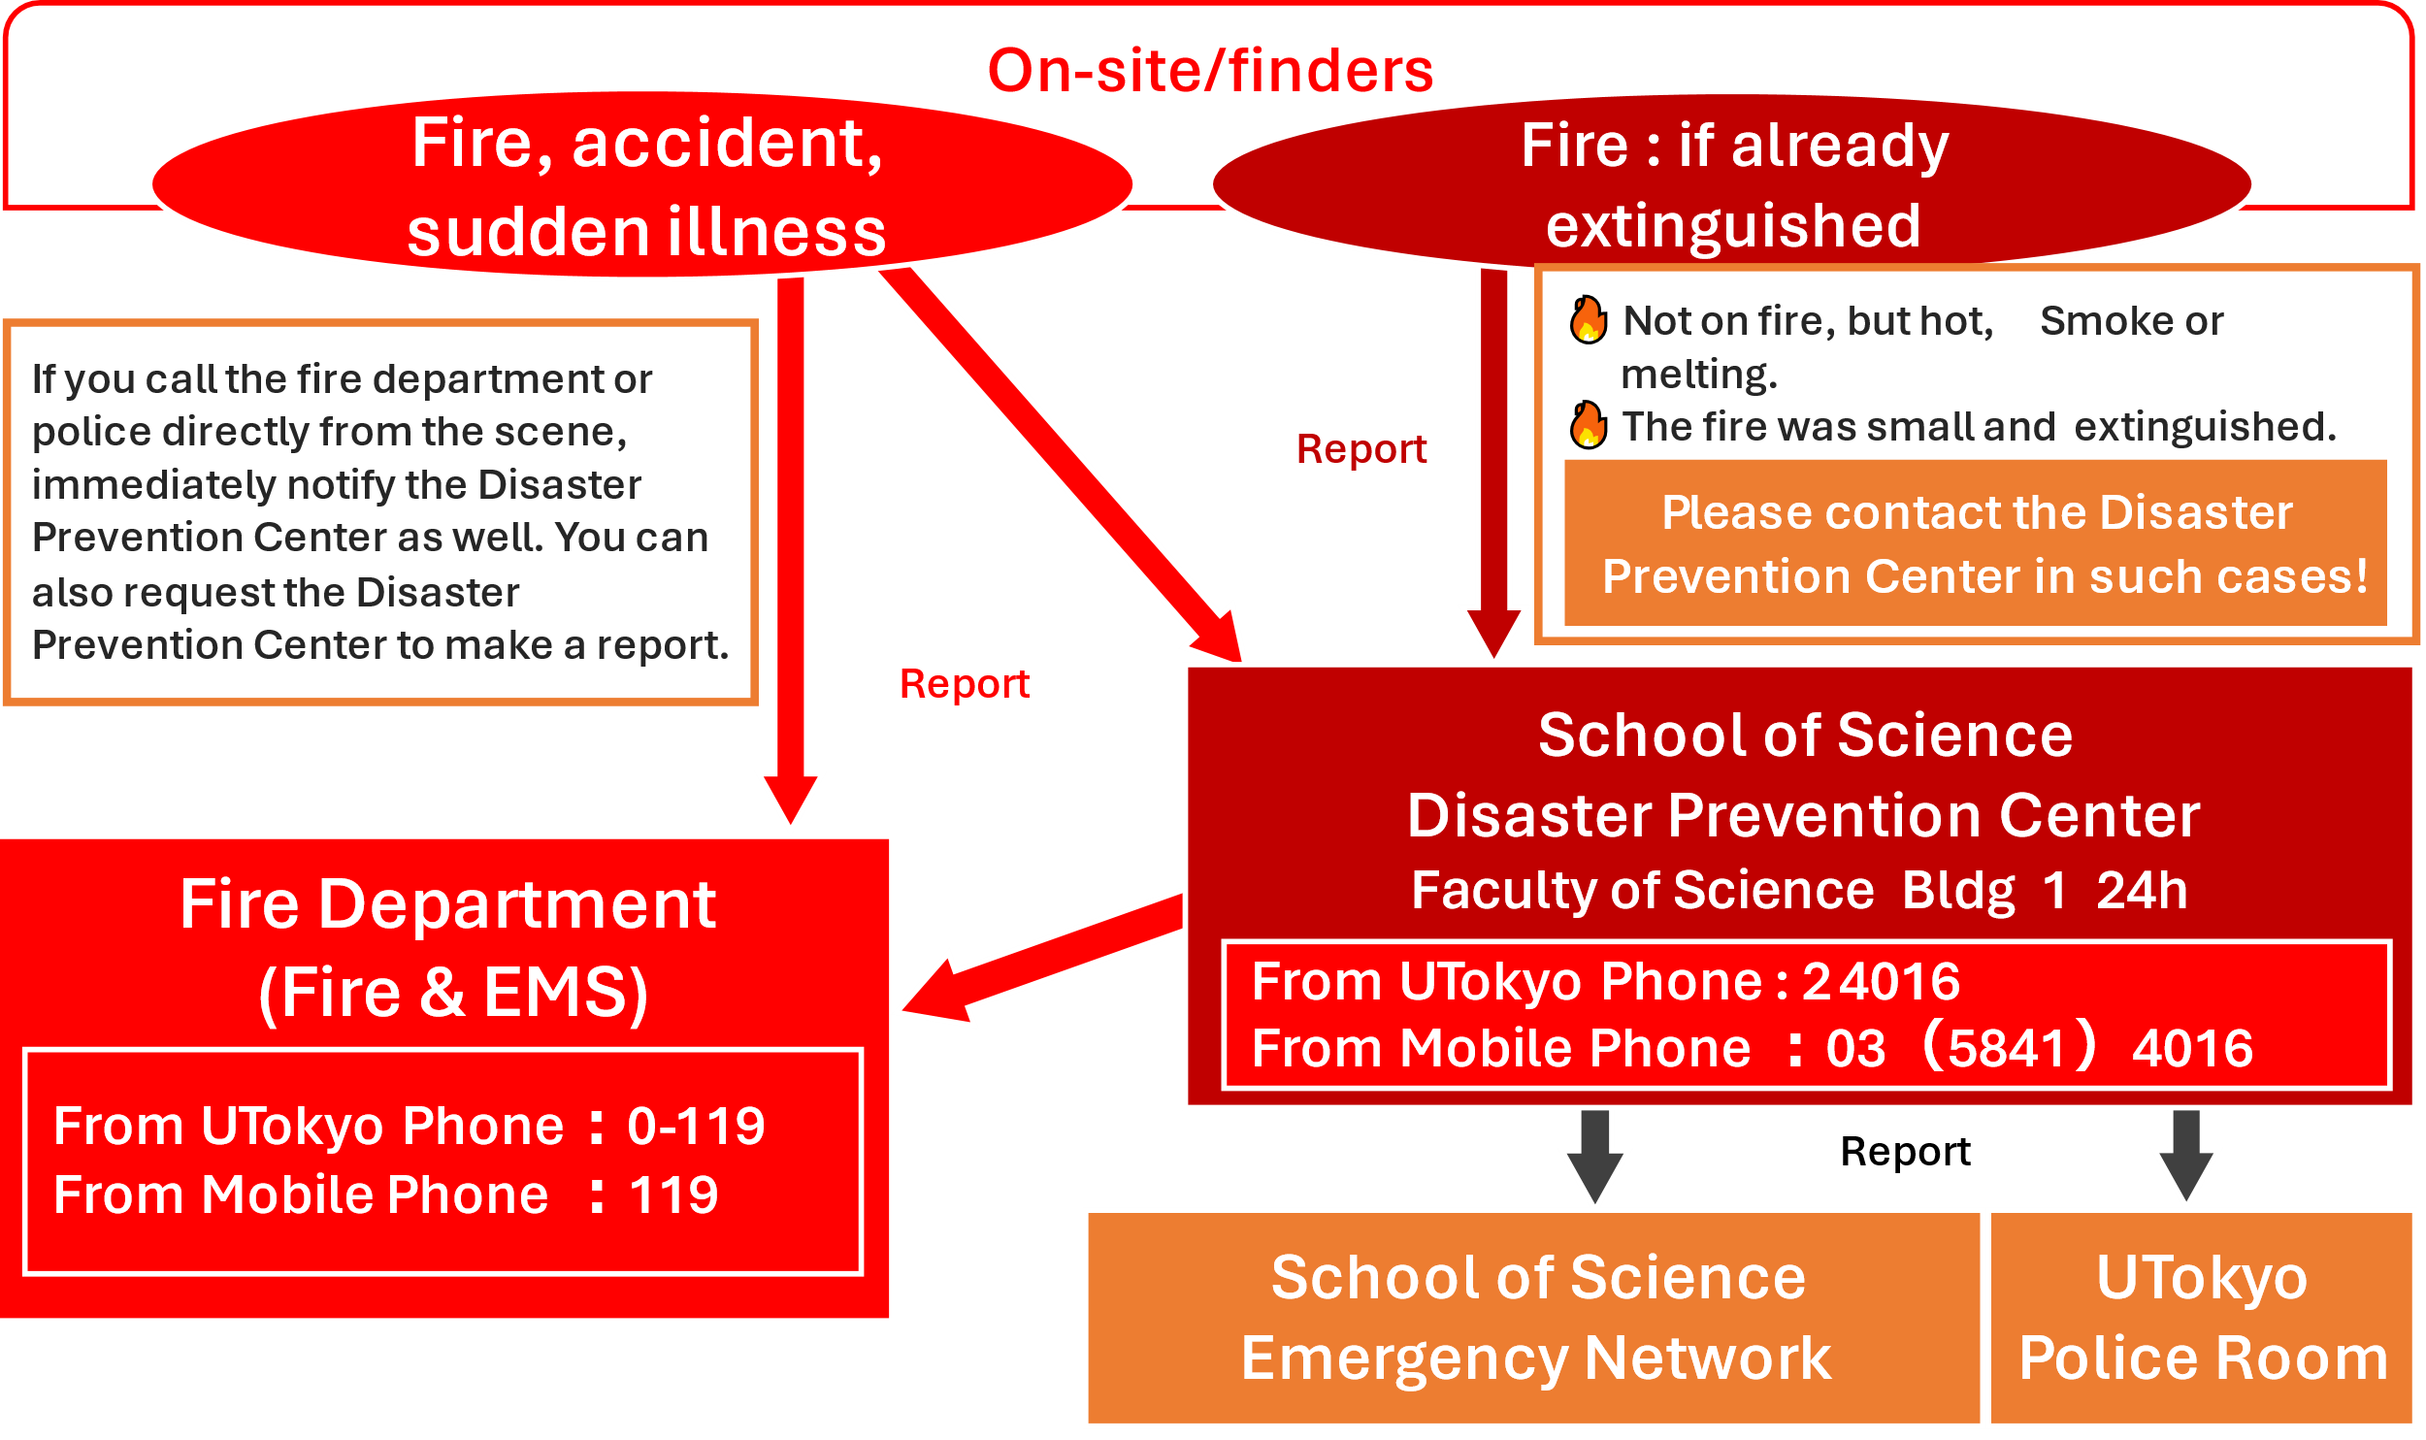　Please confirm in advance the emergency contact system of the School of Science (Figure 2) and the contact information of the person responsible for the management of your team and room (supervisor, superior, etc.) in case of sudden illness, accident, disaster, etc. Emergency contact information posters (Fig. 3) must be posted in all rooms, including laboratories, experimental rooms, and meeting rooms.

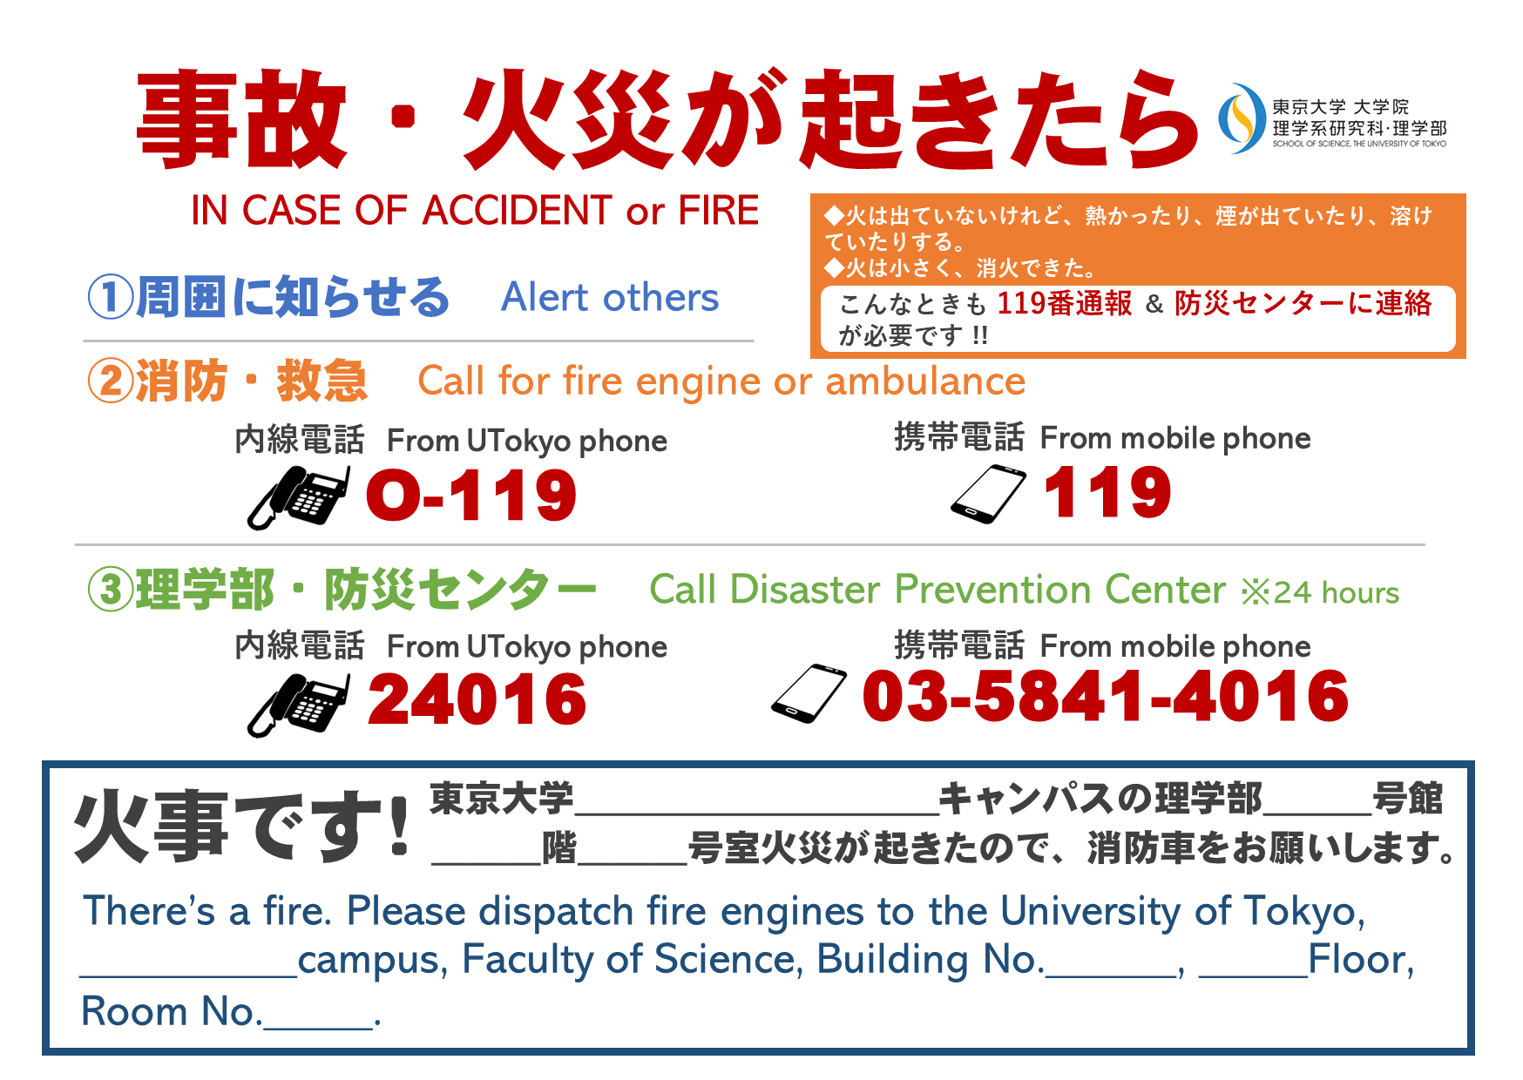Figure 2: Emergency Contacts and Emergency Contact System in the Event of Fire

Figure 3: Emergency Contact Poster

### 2.1.2　Evacuation

Check the evacuation route (two directions must be secured), emergency exit (Fig. 4), and evacuation site (P24) in advance in each laboratory/apartment. To secure the evacuation route, do not place any objects near windows, corridors, doors, corridors, or emergency stairways. Do not place any objects in front of emergency exits, fire doors, or fire shutters.

### 2.1.3　 Disaster Prevention Equipment

Confirm in advance the location and operation of AED (P25), emergency shower (Fig. 5), fire alarm/fire hydrant (Fig. 6), fire extinguisher/fire sand (Fig. 7), chemical leak prevention kit, megaphone, emergency broadcast speaker, etc.

バスルームの一角にある洗面台と人の手

**壁に貼られたポスター

**モニター画面に映る文字

中程度の精度で自動的に生成された説明Do not place any objects around fire extinguishers, fire alarms, or fire hydrants, and do not move fire extinguishers from their designated locations unless they are to be used. The location of fire extinguishers has been reported to the fire department and may not be moved without permission. Please consult with the Accounting Team Administration ([keiri-k.s@gs.mail.u-tokyo.ac.jp](mailto:keiri-k.s@gs.mail.u-tokyo.ac.jp)) regarding the location or addition of fire extinguishers.

Fig. 7 – Fire extinguishers

and fire extinguishing sand

Fig. 6 – Fire alarm and

fire hydrant

Fig. 5 – Emergency showers

Fig. 4 – Lights indicating evacuation routes

### 2.1.4　Emergency Drills

　The School of Science conducts annual disaster drills in May and October.

* Spring Disaster Drill (May): Firefighting and AED training
* Fall Disaster Drill (October): Evacuation Drill, Disaster Countermeasure Drill

### 2.1.5　Safety Confirmation in the Event of a Large-Scale Disaster

In the event of a major disaster, please be sure to notify the university about your safety. The School of Science has introduced a safety confirmation service[1] to quickly and efficiently confirm your safety. If an earthquake above the threshold occurs at your residence or commuting destination, a message will be automatically sent to your registered e-mail address. Please make sure that your contact information is up to date in the Human Resources Information System or the Academic Affairs System (UTAS). If you are unable to contact us via the Safety Confirmation Service, please contact us through your supervisor or superior.

## 2.2　Disaster Preparedness

To prevent disasters and respond appropriately when they occur, it is essential to be prepared on a daily basis. Please always pay attention to the following items and make every effort to take safety and health measures.

### 2.2.1　Security

* In general, room and laboratory doors should be kept closed whenever possible.
* When leaving a room or a laboratory, lock the door after confirming all is safe inside.
* Do not lend your key (or ID card) to anyone else. When entering a locked building or room, do not allow anyone unknown to you to enter at the same time.

### 2.2.2　Anti-toppling measures

* Secure cabinets to the walls etc. to prevent them from toppling over. Ensure that the walls etc. are firm enough to withstand substantial force.
* Take measures to prevent objects from falling off flat laboratory tables and stone tables (e.g. employ a rim or raised edge).
* Use wooden or steel cabinets with double sliding doors to store chemicals. Cabinets with double or single swing doors must not be used to store chemicals.
* Take measures to prevent objects from falling off cabinet shelves (e.g. install railings).

### 2.2.3　Fire Risk Assessment and Fire Prevention

The University of Tokyo requires fire risk assessments to be conducted at least once a year in each room on campus based on the "University of Tokyo Fire Prevention Manual". Each laboratory and office should systematically conduct a fire risk assessment to reduce risk and prevent fires.

（１）Electricity

* Compare the power consumption to the capacity of the outlet in order to prevent overheating and current leakage. Table taps must also be connected directly to the sockets.
* All electrical switches, fuses, and wires must be standard products.
* Use safe rubber tubes and PVC tubes. (Tubes that crack when twisted must not be used.) Ensure that they cannot become dislodged or contact the electrical cables.
* When leaving the workplace, turn off the power to all equipment except any that are required to operate overnight.
* To prevent tracking, remove any dust buildup on outlets and plugs.

（２）Combustibles

* Use only safe heating equipment (e.g. shockproof quality), and do not place heaters near flammable substances or objects.
* Be aware that static electricity may ignite nearby combustibles.
* Equipment that uses naked flames must be placed on fire-proof stands and inflammable articles must not be located nearby.
* Smoking is only allowed in designated smoking areas.

## 2.3　Emergency Procedures

### 2.3.1　Basics of Emergency Response

　1) **Ensure your own safety**：In the event of a disaster, the most important thing is to ensure your own

safety and act in an appropriate manner in accordance with the scale of the emergency. Prioritizing your own safety not only prevents injury, but it also enables you to act swiftly to report or cope with the situation after disaster strikes.

2) **Alert others and report**：It is important to promptly notify the fire department and also to let others know in a loud voice. Please refer to the back cover of this manual for emergency contact information and keep it available for reference at all times.

3) **Take necessary measures (put out fires / help others)**：Do not respond or make decisions on your own, and cooperate with others as much as possible to deal with the situation.

### 2.3.2　Response to Fire

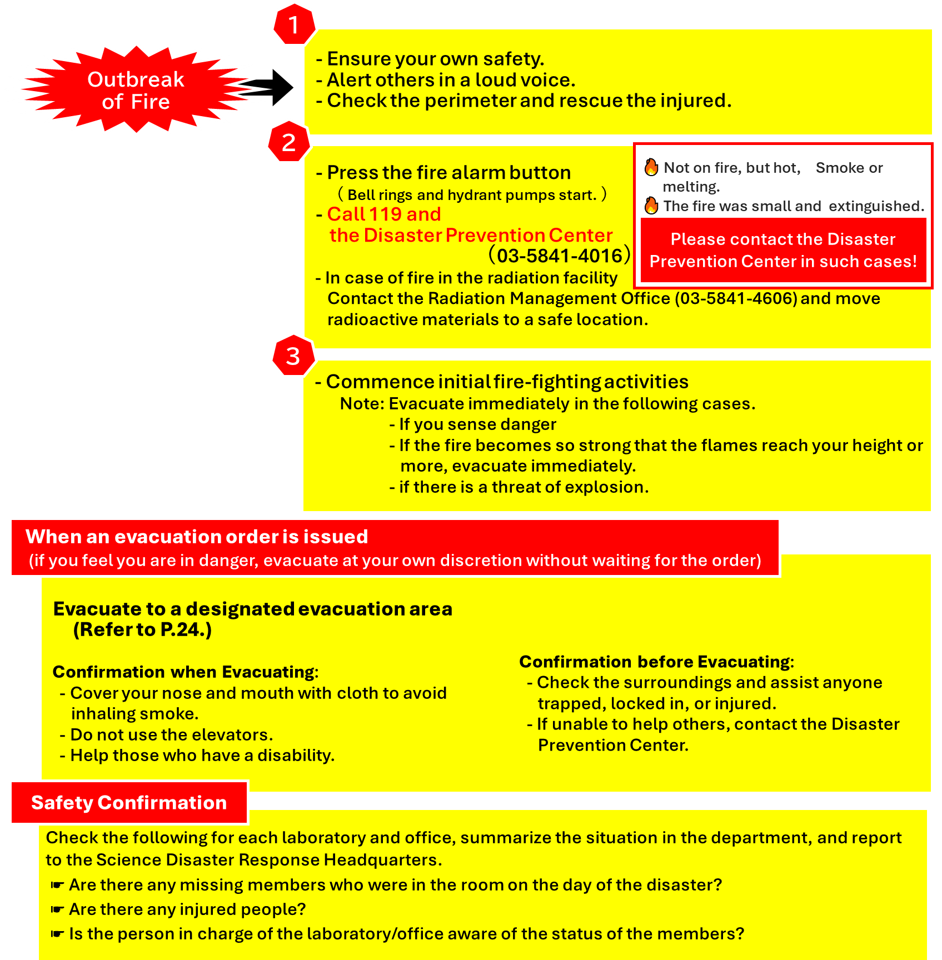　 The following are basic responses in the event of a fire.

### 2.3.3　Response to Explosions

　The following is a basic response in the event of an explosion.

* Check the surroundings and assist anyone who has been injured.
* Contact the Disaster Prevention Center immediately.
* Immediately secure the device that caused the explosion to prevent further hazard. If this is difficult, and if there is a danger of a further explosion, evacuate the premises immediately.
* There is a risk of secondary accidents nearby due to shock waves or flying debris, so be sure to check the surroundings in addition to the source of the explosion.
* In the event of a fire, take necessary measures as per “4.2 Response to Fire”.

### 2.3.4　Response to Chemical Leaks

　The following is a basic response to a chemical leak.

* If the chemical is highly toxic, inform the people around you and evacuate the premises immediately. If necessary, evacuate the entire building.
* If possible, stop the leak and prevent it from spreading.
* In the event of large quantities of acid entering the sewers, contact the Waterworks Bureau (03-5343-6209 for Hongo Campus) directly.
* In any case, contact the Disaster Prevention Center immediately.

### 2.3.5　Response to Earthquakes

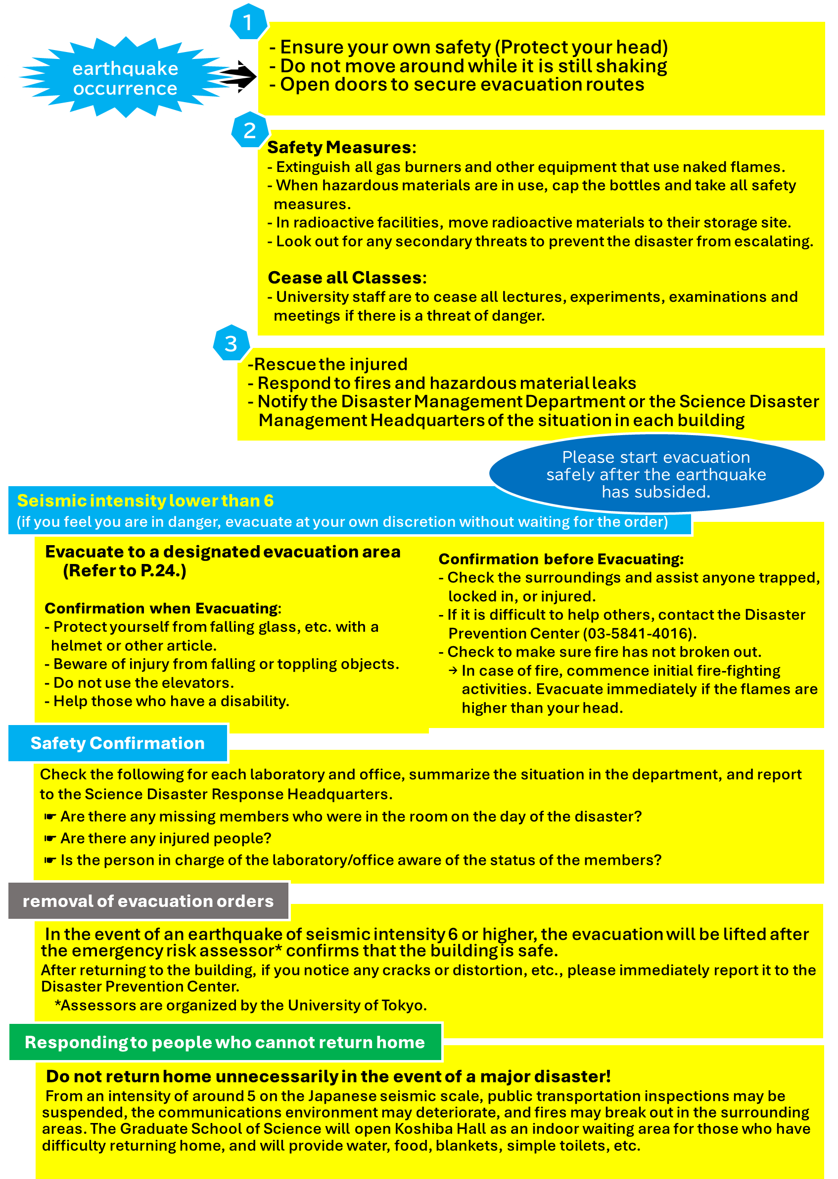　The following is a basic response in the event of a major earthquake.

### 2.3.6　Response to Accidents

The following is a basic response in the event of an accident.

* In the event of an accident, injury or illness, contact the hospital or Fire Department as appropriate based on the situation. In any case, contact the Disaster Prevention Center immediately.
* Report the details to the manager of the office/laboratory, the department office, and ESMO.
* 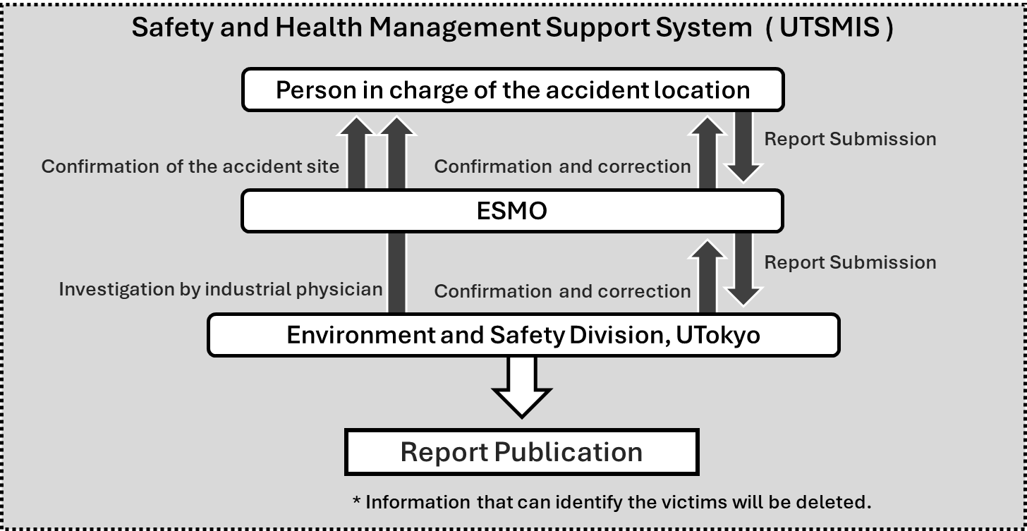After discussion with the person concerned and the manager of the office/laboratory, submit a report on the accident via the online University of Tokyo’s Safety Management & Information System (UTSMIS) <https://utsmis.adm.u-tokyo.ac.jp/UT_Anei_User/>

Figure 8: Accident and Disaster Reporting Flow

* Refer to “5. Labor Basics for University Constituents”.

### 2.3.7　 Automated External Defibrillators (Using AEDs)

AEDs are cardiopulmonary resuscitator units that can revive people whose hearts have stopped beating.

These are medical devices for restoring one’s pulse, and involve the application of electric shocks to the chests of patients whose hearts have stopped beating.

If you find someone lying prone:

1. Tap them on the shoulder and speak to them.
2. If there is no response, shout for help and ask passersby to call 119 and bring an AED unit.
3. Check the person’s respiration – i.e. Are they breathing?
4. If respiration is normal, immediately commence with 30 chest compressions (heart massage).
5. After the chest compressions, perform artificial respiration twice.
6. When the AED unit arrives, first of all switch on the power. Then following the audio instructions 　　　provided.

Anyone can easily use an AED by following the audio instructions, but it is important to confirm once in advance how to use it. The School of Science conducts emergency drills including AED training every spring, and students can also participate in regular training sessions held by the fire department.

Locations of AEDs in the buildings of The School of Science in the Hongo and Asano areas are listed on p. 25.

# ３．Waste Disposal

Waste should be properly classified and disposed of in accordance with laws and regulations and the separation rules set by the Environmental Safety Research Center.

## 3.1 Daily-life waste

 Please separate daily-life wastes according to the rules in Table 1 below.

Table 1: Separation of daily-life wastes

## 3.2　Laboratory Waste

See p. 22 for more information on laboratory wastes.

## 3.3　Special Waste

Large unneeded items, PC-related unneeded items, fluorescent lamps, dry batteries, paint, spray cans, mercury waste, asbestos, and other special waste are regularly collected by waste type. Please answer the survey on the quantity of waste prior to collection and dispose of the waste according to the instructions. If you are unsure of the disposal method, please consult with the ESMO to determine the disposal method.

# ４.　 Precautions in office work

## 4.1　Prevention of Health Problems Caused by Working with Information Equipment

When working on information equipment for long periods of time, please take the following precautions to reduce the physical and mental burden and to maintain good health. The person in charge of the laboratory/office should properly manage the environment so that the members can work without any problems.

1. Work Environment Control

* The brightness of the room should be as bright as possible without significant contrast between light and dark and without glare.
* Select and install equipment that is most suitable for the work to be performed by the worker.
* Chairs should be installed with seat heights that can be adjusted appropriately according to the worker's body shape.

More than 40cm

* 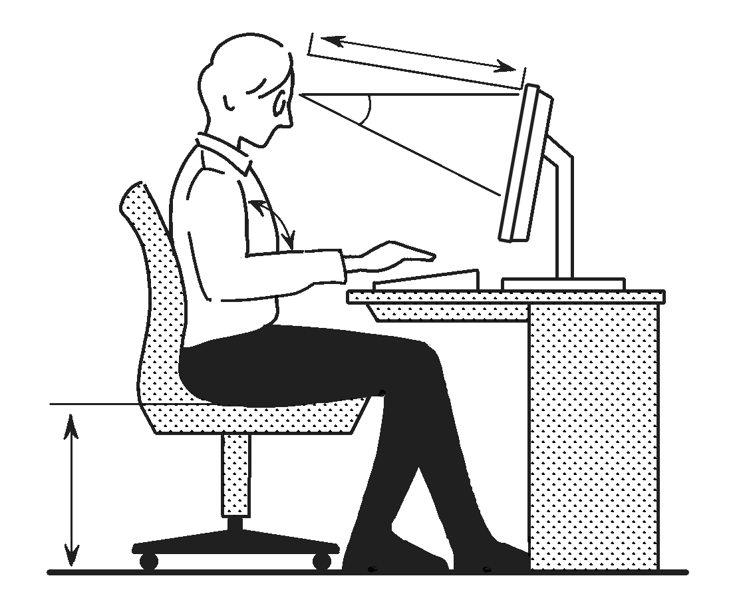Desks or worktables with an average height of 65-70 cm are desirable.

30°

* Noise emissions from information equipment, etc., should be reduced.

90° or more

1. Work Management

* The continuous working time should not exceed one hour, with a 10 to 15 minute pause period.
* The display should be set up so that the viewing distance to the display is approximately 40 cm or more and the screen is positioned below the horizontal line of sight.

0.23 x height

　　　　　　　　　　　 Figure 9: Work environment adjustment and work posture

when using information equipment

## 4.2　 Health care while telecommuting

When teleworking from home, it is equally important to maintain an appropriate work environment. Please take the following precautions to maintain your physical and mental health.

* Provide sufficient space for work to be performed.
* Arrange equipment appropriately so that work can be performed in a comfortable posture.
* Keep things neat and tidy so that they do not fall over during work.
* Ensure adequate lighting for work.
* Provide adequate ventilation when working.
* Adjust the temperature and humidity to a level suitable for the work.
* Take measures to reduce noise that may interfere with work.
* Ensure an environment that allows adequate hydration and breaks.
* Know the contact information of the person in charge and the contact person to consult with if there is a major change in the work environment at home or if you feel a physical or mental health problem.

## 4.3　Back Pain Prevention

When handling heavy objects, take the following precautions to prevent back pain.

* One person can handle no more than 55 kg or 40% of his/her body weight.
* Keep your body as close to the object as possible and adopt a posture that lowers the center of gravity.
* When lifting a load, put one foot slightly forward, bend the knees, lower the hips enough to lift the load, and then stand up by extending the knees.
* Stand up by bending over and extending the knees.
* To reduce the need to bend over, use a workbench of appropriate height.
* When carrying a load, keep the back straight to minimize twisting at the waist.

Fig. 10 – Picking up heavy objects.

# 5.　Labor Basics for University Members

## 5.1　Faculty

　Faculty members in employment with the University of Tokyo are eligible for

### 5.1.1　 Occupational Accidents

　Occupational accidents refer to injuries, illnesses, disabilities, or deaths that occur at work.

1. Requirements for recognition

Engaged in task: The employee was under the employer’s supervision/instruction.

Origin of task: The employee incurred the injury etc. while fulfilling his/her job description.

1. Compensation

Actual payment of medical fees, etc., as compensation, and compensation for absence from work. Disability payment, or payment to the bereaved in the event of death, etc.

1. Applying for compensation

In order to qualify for compensation, the person who suffered injury or illness, etc., or his/her family must apply for compensation at the relevant Labor Standards Inspection Office. Submit the Accident Report and obtain an employer certificate of occupational accident from the Department Office before applying. In principle, the application should be submitted within two years of the accident (or five years for the payment of disability or bereaved family compensation).

### 5.1.2　 Occupational Accidents under Special Circumstances

　The following cases are also covered by occupational injury.

* Accidents during work-breaks: Accidents are recognized as occupational accidents if they resulted from deficiencies in the safety of the facility or failings in management.
* Accidents during business trips: Employees are considered to be on duty while on business trips, and as such, accidents that occur during business trips are regarded as occupational accidents, except when caused by a private activity.

### 5.1.3　 Commuting Accidents

* Commuting accidents refer to injuries, illnesses, disabilities or deaths sustained while commuting to or from work. Although commuting accidents differ from occupational accidents, they are handled similarly.
* If there are any deviations from the normal commuting route or means of travel, the accidents are not considered commuting accidents. However, the following activities are not regarded as deviations:

1. Purchasing daily necessities, or a similar activity
2. Participating in professional training, education at school, etc.
3. Voting in a government election, or a similar activity
4. Consulting or receiving treatment at a hospital, clinic, etc., or a similar activity.

## 5.2　Students

Students affiliated with the University of Tokyo are eligible for

### 5.2.1　 Accident Insurance for Students

All students affiliated with the University of Tokyo are covered by the Student Accident Insurance for Education and Research (with a special clause for commuting to and from the University). In the event of an accident during education and research activities or while commuting to and from the University, the insurance premiums will be paid. Please report the accident to your department office and complete the insurance claim procedures.

# ６.　 Health Care and Consultation Services

## 6.1　Health Care

### 6.1.1　Health Examinations

Faculty, staff, and students are required to undergo medical examinations conducted by the University at regular intervals to maintain their health. In particular, faculty and staff in employment with the University of Tokyo are obligated to maintain their own health according to the Occupational Health and Safety Law.

　Members who work in hazardous operations or handle hazardous substances are subject to the health checkups for specified workers and special health checkups, regardless of whether they are faculty, staff, or students. Please ensure that you receive appropriate medical examinations in response to investigations by the department in charge.

### 6.1.2　Mental Health

If you suffer any of the following symptoms, seek a consultation with a medical professional promptly:

1. Sleep time is not constant and interferes with daily life.
2. Not feeling like doing anything.
3. Feeling a sense of extreme disinclination toward work.

### 6.1.3　Consultation Service

* 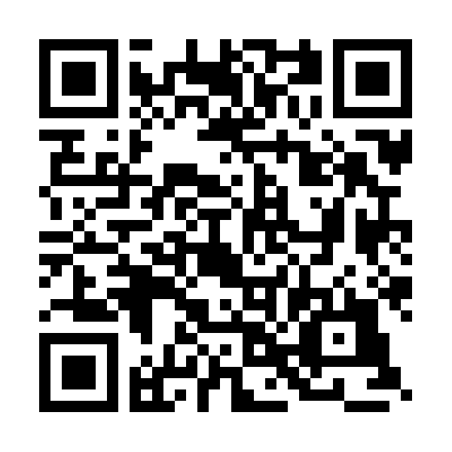Occupational Health Office

The Occupational Health Office provides consultation mainly to faculty and staff regarding mental and physical problems associated with their work. Students can also receive consultations regarding health concerns caused by experiments, etc.

Inquiry Form: <https://sites.google.com/a/ohs.adm.u-tokyo.ac.jp/top/home/soudanmadoguti>

* Mental Health Support Office

Psychiatrists provide medical care and mental health support for students, faculty and staff. Medication and counseling by a clinical psychologist are also provided as needed. Please see the website for details on how to use the service.

WEB: <https://dcs.adm.u-tokyo.ac.jp/mhs/guide/>

* Student Support Office

Clinical psychologists provide a wide range of counseling services for students, from academic counseling to future career paths, daily life concerns, and mental health.

Inquiry Form: <https://www.s.u-tokyo.ac.jp/ja/soudan/form.html>

## ６.2　Harassment Response

The University of Tokyo is committed to preventing all forms of harassment in order to guarantee an educational, research, and working environment in which all members are respected as individuals and can operate autonomously and safely.

### 6.2.1　Consultation Service

The privacy of the consultants is strictly protected. You will not receive any disadvantageous treatment for consulting with us.

* Harassment Counseling Center UTokyo

WEB: <https://har.u-tokyo.ac.jp/>

Please refer to the web for the person in charge of each major and department.

WEB: <https://www.s.u-tokyo.ac.jp/ja/offices/harassment/members.html>

# 7. Specialized Matters to be Observed when Carrying Out Research Activities

When conducting experiments and research activities at UTokyo, you are expected to understand your social responsibilities and comply with laws and ethics related to health and safety. Please understand the basics of safety management and conduct your experiments and work accordingly.

## 7.1　 Principles of Safety Management

1. Learn about the potential hazards of substances and equipment.

* Check applicable laws and regulations.
* Conduct Risk Assessment for experiments.
* Safety Data Sheets (SDS) are useful for obtaining information on a substance.

1. Establish safety measures to avoid creating potential hazards.

* Consider replacing high-risk substances/equipment with lower-risk alternatives.
* Change the experimental method.
* Consideration and preparation of protective measures, etc.

1. Carry out laboratory work with adequate safety measures in place.

## 7.2　 Precautions during Experiments

When conducting experiments, please pay attention to the following.

* Keep the laboratory clean and uncluttered at all times.
* Do not leave unnecessary chemicals on the laboratory bench. In particular, do not leave chemical containers unattended on the floor.
* Choose and wear appropriate protective equipment such as protective goggles, gloves, white lab coat, etc. appropriate for the experiment.
* In general, do not carry out very dangerous or hazardous experiments during the weekend or after-hours. Such experiments must be attended by more than one person.
* Know the location of emergency exits, as well as the location, type and handling of fire extinguishers in case an accident occurs.
* Ensure that all the precautions that are required for unattended machine operations are in place, and display emergency contact numbers near the entrance of the laboratory or where clearly visible.
* When carrying out experiments, always adopt a serious attitude. Most accidents occur because familiarity with the operation leads to reduced attention.

## 7.3　 Management of Chemical Substances

Chemicals and high-pressure gases must be controlled in accordance with laws and campus regulations.

### 7.3.1 Chemicals and High-Pressure Gas Management System (UTCIMS)

　UTokyo manages all chemicals and high-pressure gases stored and used, from inventory control to use and disposal, using the UTCIMS management system.

### 7.3.2　 Hazardous Substances and Legal Regulations

　When handling the following chemical substances, you must be aware of their hazards and legal requirements and take adequate safety measures. If legal procedures are required, please consult with ESMO and follow the appropriate procedures.

1. Organic solvents (Class 1, Class 2 and Class 3): Ordinance on Prevention of Organic Solvent Poisoning, Industrial Safety and Health Law
2. Specified chemical substances (Type 1, Type 2 and Type 3): Ordinance on Prevention of Hazards due to Specified Chemical Substances
3. Poisonous substances and specified poisonous substances: Poisonous and Deleterious Substances Control Law
4. Deleterious substances: Poisonous and Deleterious Substances Control Law
5. Narcotics: Narcotics and Psychoactive Drugs Control Law
6. Psychoactive drugs: Narcotics and Psychoactive Drugs Control Law
7. Stimulants: Stimulants Control Law
8. Chemical substances regulated by PRTR Law (Class 1 and Class 2): PRTR Law, Metropolitan bylaw
9. Hazardous substances (Type 1, Type 2, Type 3, Type 4, Type 5 and Type 6): Fire Services Law
10. High-pressure gases and Gases with Special Components: High-pressure Gas Safety Law
11. Radioisotopes (RI) (See section “7.4 Radiation and Radioisotopes”)
12. Biohazardous materials (See section “7.5 Biosafety”)

　Potentially hazardous chemical substances and chemical waste must be treated with sufficient safety measures, even if they are not regulated by law.

### 7.3.3　 Precautions for Handling Hazardous Substances

　Any person transporting or handling a hazardous substance must fully understand the nature of the substance. In principle, do not allow any person who has not been educated on hazardous substances to handle them.

（1）Before using hazardous substances

* Minimize the use of substances that are considered highly hazardous due to their toxicity, flammability or explosiveness. Efforts to minimize the use of such substances must be taken when drawing up the study protocol. For example, consider whether the use of that substance is absolutely necessary, or whether it can be substituted with another substance.
* Consider and prepare thoroughly to prevent disasters caused by the substance. If the substance has the potential to cause a fire or explosion, place fire extinguishers nearby and work with respiratory protective equipment and heat resistant clothing. If a substance has the potential to cause poisoning, wear rubber gloves, a respiratory mask and protective clothing.

（2）Using hazardous substances

* Before conducting a potentially hazardous experiment, inform the people nearby, and take appropriate safety measures.
* Experiments must be designed so that the least possible amount of hazardous substance is used, and if the nature of a substance is unknown, a preliminary experiment must be conducted.
* When opening glass ampoules containing hazardous liquids, prepare a sealed container and open them inside it to prevent the hazardous substance from being spilled.
* Hazardous substance must not be disposed of with non-hazardous waste. Refer to “7.8 Laboratory Waste” when you dispose of any chemical substances.

（3）Surrounding conditions

* Do not use an open flame heater in a laboratory where a volatile solvent is used.
* Know the locations of fire extinguishers. If there is a risk of fire, ensure, in advance, that a fire extinguisher is close to the work area.
* Turn off the main valve of the gas supply whenever no one will be staying in the room.

　（4）Storing hazardous substances

* Inspect the storage conditions and quantities of hazardous substances when it is considered appropriate, and continuously implement measures to ensure health and safety.
* Use a solid container with a cap or stopper that will prevent the substance spilling, leaking or evaporating. During storage, ensure that all containers of chemical substances and of waste liquids are closed.
* Generally, store hazardous substances in a cool place and away from direct sunlight and ignition sources such as sparks and heat. Do not store substances with different characteristics in the same location.
* Ensure that stored containers cannot be damaged as a result of falling over, falling from the shelf or colliding, even during an earthquake. Store hazardous substances separately to prevent a fire or explosion caused by spilt substances interacting.
* If a hazardous substance is missing or stolen, the loss must be reported to the chemical substance manager so that measures may be taken to prevent the substance causing an accident.

### 7.3.4　 Management Required by Regulations

#### 7.3.4.1 Health and Safety Management required by OPOSP and OPHSCS

When dealing with substances designated by the Ordinance on Prevention of Organic Solvent Poisoning (OPOSP), the Ordinance on Prevention of Hazards due to Specified Chemical Substances (OPHSCS), and the Industrial Safety and Health Law, the following management is required.

（１）Managing the Work Environment

* Preventing vapor and dust discharge (using a fume hood)
* Assessing the work environment (twice per year)

（２）Managing Work Procedures

* Establishing safe work procedures
* Using personal protective equipment

（３）Health Management

* Understanding measures to prevent sickness and injury and knowing first aid.
* Undertaking specialized medical checkups (twice per year)

（４）Others

* Signs and displays referring to the substances being used, and precautions.

#### 7.3.4.2　Management required by the Poisonous and Deleterious Substances Control Law

* When preparing, importing, or buying (receiving) poisonous substances, a license is necessary.
* Use UTCIMS to manage the quantity of all substances purchased, used, or disposed of, and record the date and name of the person involved.
* The faculty staff members are responsible for handling the storage keys.
* Containers must be labeled as “Poisonous Substance Not for Medical Use” or “Deleterious Substance Not for Medical Use.”
* Store separately from other chemicals in a locked chemical cabinet or other storage area.
* Use protective equipment as needed when handling such substances.

#### 7.3.4.3　Management required by Narcotics and Psychoactive Drugs Control Law

（１）Narcotics

* When buying (receiving) narcotics, a narcotics research license is necessary.
* The narcotic researcher is responsible for management of the narcotics.
* Notification is necessary whenever a narcotics researcher moves to another site, the storage place is changed, or the narcotics are disposed of.

（２）Psychoactive Drugs

* When buying (receiving) a new psychoactive drug, notification as a “Psychoactive Drug Research Laboratory” is necessary. Although the School of Science has already submitted such notification, any researcher who intends to use psychoactive drugs must tell the ESM OFFICE immediately, because management of the research laboratory is necessary.
* A manager and the researcher involved in the laboratory concerned are responsible for management of the psychoactive drugs.
* Any change in the storage place, etc. must also be notified to the ESM OFFICE.

（３）Stimulants and their constituents

* When buying (receiving) stimulants or their constituents, the researcher must be designated as a stimulant researcher.
* The stimulant researcher is responsible for management of the stimulants and their constituents.
* Notification is necessary whenever a stimulant researcher moves to another site, the storage place is changed, or the stimulants and their constituents are disposed of.

#### 7.3.4.4　Management required by Stimulants Control Law

* Ensure that stored containers cannot be damaged as a result of falling over, falling from the shelf, or colliding. Substances that are potentially hazardous when mixed (e.g. a combination of an oxidizing substance [Type 1 or 6] with a flammable substance [Type 2 or 4]) must not be stored in the same location.
* When substances are stored at one fifth or more of the maximum quantity specified by law, this situation must be reported in accordance with the law.
* In the storage or handling area, possible ignition sources must be strictly controlled, and fire-fighting equipment must be installed.
* Use appropriate protective equipment, such as goggles and shields, in order to ensure personal safety.

## 7.4 Radiation Control

　When conducting experiments and research which requires handling radiation and/or radioactive materials, including the use of accelerator facilities, X-ray equipment, and electron microscopes, proper safety control must be exercised by observing the "Act on the Regulation of Radioisotopes, etc." and related laws, "Regulations on Prevention of Ionizing Radiation Hazards" and university regulations, and the radiation hazards prevention program of the School of Science at the University of Tokyo.

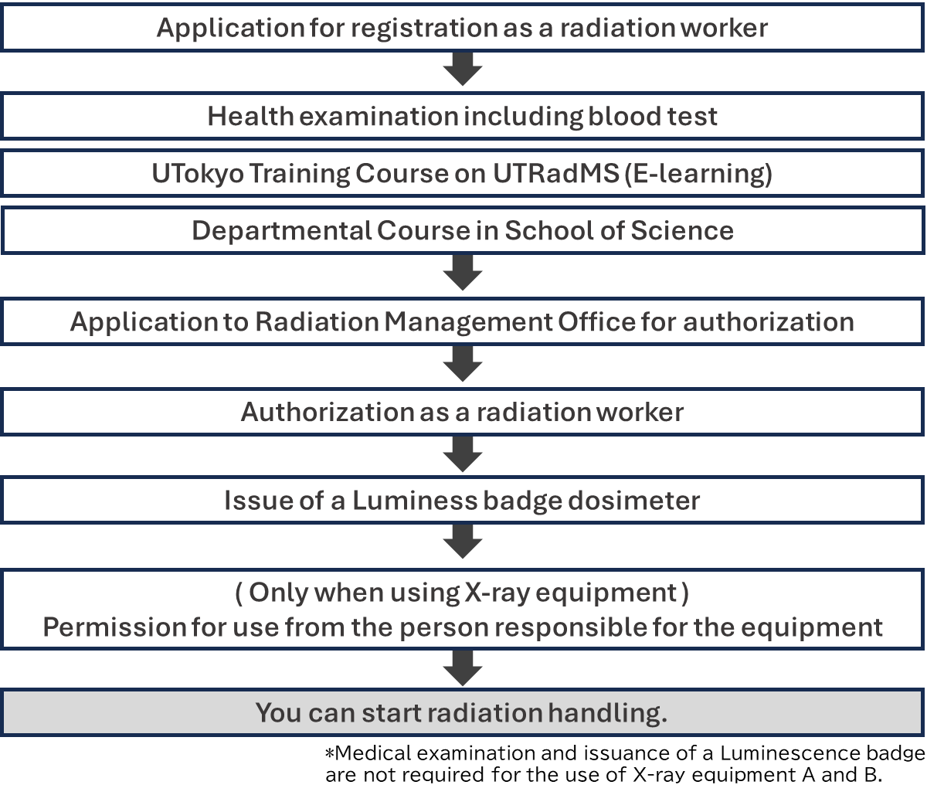　When conducting relevant experiments and research, apply for registration and authorization as a radiation worker through the UTokyo Radiation Management System (UTRadMS), and receive training on handling radiation.

Fig. 11 Procedures for starting to use radiation facilities and equipment.

　When using radiation facilities outside the School of Science, or even outside the university, you must have a certificate of authorization as a radiation worker registered at the School of Science, the University of Tokyo.

* Contact

**Radiation Management Office, School of Science, The University of Tokyo**

E-mail: [ri-s-group@g.ecc.u-tokyo.ac.jp](mailto:ri-s-group@g.ecc.u-tokyo.ac.jp)

Web：<https://ri.adm.s.u-tokyo.ac.jp/>

## 7.5　 Biosafety

When conducting experiments in which organisms or their metabolites may pose a risk to humans or the environment through the artificial manipulation of organisms, it is necessary not only to ensure the safety of the parties involved, but also to give constant consideration to the impact on the environment and other factors.

UTokyo provides university-wide support for research requiring ethical review (clinical research, epidemiological research, research using human ES cells, etc.) and research requiring compliance with related laws and regulations (genetic modification experiments, animal experiments, experiments using specific pathogens, etc.) through the "Life Science Research Ethics Support Office". If you wish to conduct such research or experiments, please refer to the website and follow the necessary procedures and be sure to attend the relevant training sessions.

* Contact

**Office for Life Science Research Ethics and Safety, UTokyo**

TEL：ext. 21580、03-5841-1580

E-mail：[lifescience.adm@gs.mail.u-tokyo.ac.jp](mailto:lifescience.adm@gs.mail.u-tokyo.ac.jp)

Web：<https://lsres.adm.u-tokyo.ac.jp/>

Contacts at The School of Science

Research Support and External Funding Team, Accounting Section

（ext. 28084、E-mail: [kenkyu-s.s@gs.mail.u-tokyo.ac.jp](mailto:kenkyu-s.s@gs.mail.u-tokyo.ac.jp)）

## 7.6　 Equipment Management

When handling high-temperature, high-voltage, high-velocity, or high-weight equipment, take adequate protective measures and handle with care, paying attention to the following.

* When handling specific equipment for the first time, take extra care by carrying out appropriate preparations and, if possible, examine every part of the equipment. Seek expert advice before use.
* Equipment that requires experience and practice must be handled only after the basic operational skills have been acquired. Carelessness may cause a serious accident.
* All equipment must be properly cleaned at the end of each experiment. If any defect is found, repair it or report it to the next user.
* Keep the work area organized to avoid unnecessary noise, vibration and odor. For example, improve work procedures by choosing low-noise and low-vibration equipment.

## 7.7　Protective Equipment Management

When handling chemicals and equipment, it is important to select and wear appropriate protective equipment to prevent accidents.

* Protective equipment must always be ready for use, and the person who is carrying out the experiment, either staff or student, must know the locations of such equipment.
* All personnel must receive training and acquire the knowledge required to use the protective equipment correctly.
* Take special care to disinfect and maintain the protective equipment after use.

## 7.8　Laboratory Waste

In order to continue our educational and research activities, it is necessary to take measures not only to protect our laboratory’s environment, but also to minimize any negative affect on the neighboring area.

With the Environmental Science Center as a core, we have been trying to minimize and neutralize waste at the university.

In principle, waste should be disposed of responsibly at its source, such as by individuals or laboratories. Please follow the rules and dispose of waste appropriately for each of the following types.

1. Chemical Hazardous Waste

* **Liquid/Solid Waste (Discharged to the Environmental Safety Research Center)**
* Dispose in accordance with regulations of the Environmental Science Center. The waste generator must attend the Environmental Science Center lecture and obtain a disposal qualification.
* Prepare a laboratory waste disposal request slip (waste slip) in UTCIMS and discharge the waste at the determined periodic collection. Refer to ESMO WEB for collection dates, etc.
* **Waste reagents (Outsource processing to a defined outside contractor)**
* Waste reagents which remain in the same bottle as when purchased or whose name is clear.
* Twice a year, notify ESMO in advance of the planned discharge volume and request collection.

1. Biological Waste

* Petri dishes containing adherent material (limited to agar medium) should be sterilized, placed in a special autoclave bag, and disposed of at a collection point (the "Petri dishes containing adherent material" cart).

1. Pseudo Infectious Waste

* Syringes, needles, gloves and petri dishes that are confusingly similar to those used for medical purposes should be treated as equivalent to infectious waste. Contact the safety office of each department and entrust disposal to a disposal company contracted collectively by the University of Tokyo.

1. Radioactive Waste

* Follow the instructions of Radiation Management Office.

1. Others

For the following items, refer to the Office of Environmental Safety Management WEB for scheduled collection dates, etc.

• Mercury waste (including fluorescent lamps and dry batteries)

• Paint and spray cans

• Items containing CFCs (air dusters, etc.)

# 8.Education and Research Activities during Field Work

Fieldwork, field observation, research using observation vessels, field training, field trips, and other outdoor educational and research activities involve a variety of hazards that are different from those found indoors. Because of the potential for serious and possibly fatal injuries, UTokyo has established a clear system of responsibility for outdoor activities[2], and each principal investigator is responsible for the health and safety management and accident prevention of his or her team. Each participating member of the team is also responsible for taking all necessary precautions to ensure health and safety management and accident prevention.

The minimum precautions to be taken when conducting outdoor activities are summarized in the "Guidelines for Health and Safety Management and Accident Prevention in Outdoor Activities" published by the Environmental Safety Division of the University of Tokyo. When conducting field research, please refer to these guidelines and plan accordingly to prevent accidents.

## 8.1 Submission of Health and Safety Management Plan

When conducting outdoor activities, please submit a "Safety and Health Management Plan for Outdoor Education and Research Activities" to ESMO at least one week prior to the activity.

Details on the form and submission of the plan are posted on the web of ESMO.

## 8.2　Use of Drones

To use a drone outdoors, please submit a "Flight Application" to ESMO and obtain approval from the dean of The School of Science.

The application form and submission details are available on ESMO Web.

## 8.3　Bee Sting Prevention

Members who conduct educational and research activities or facility operation work outdoors where bees are expected to be present should refer to the "[The School of Science] Bee Sting Disaster Prevention Guidelines (1st Edition)" established by The School of Science and strive to prevent accidents.

If you wish to conduct practical training or work in areas where there is a risk of bee damage, you may receive a prescription for an EpiPen (anaphylactic adjuvant) at the Health Center in advance. Please contact the Environmental Safety Office or your nearest campus health center.

# Appendix

## The School of Science Designated Evacuation Site

## QR コード 自動的に生成された説明マップ 自動的に生成された説明Map of AED locations for the School of Science

## Contact Information in Emergencies

|  |  |  |  |  |
| --- | --- | --- | --- | --- |
|  | **What to do** | **Contacts** | **TEL** | **What to report** |
| **Disease/Injury** | 1. Turn off the power supply.  2. Alert people nearby.  3. Apply first aid treatment.  Bleeding: Compress with a towel.  Unconscious: Use AED.  4. Stay calm. Call the numbers listed to the right.  5. If the injury is not serious, take the injured person to the hospital emergency room. | 1. Hospital  emergency room | ext. **34100**  Outside line or  mobile phone  **03 (5800) 8683** | of the Faculty of  Science is injured, and will be taken to the hospital. |
| 2. Fire Department  (when calling for an ambulance) | ext. **0119**  Outside line or  mobile phone  **119** | Send an ambulance. There is an injured/sick person in Room __ on the __th Floor of the ___ Building of the Faculty of Science, XX Campus of the University of Tokyo. The address is XXX, and my name is XXXX. |
| 3. Disaster Prevention Center, Faculty of Science | ext. **24016**  Outside line or  mobile phone  **03 (5841) 4016** | There is an injured/sick person in Room __ on the __th Floor of the ___ Building of the Faculty of Science. An ambulance has been called. Please guide them here. |
| **Fire** | 1. Alert people nearby.  2. Turn off the power supply.  Close gas valves.  3. Stay calm. Call the numbers listed to the right.  4. If the fire is small, try to extinguish it.  If the fire is large, evacuate.  **If there is no fire but smoke or something melted, or in case of successing to put out the fire, please call 119 and Disaster Prevention Center for sure.** | 1. Fire Department | ext. **0119**  Outside line or mobile phone  **119** | Send a fire engine. There is a fire in Room __ on the __th Floor of the ___ Building of the Faculty of Science, XX Campus of the University of Tokyo. The address is XXX, and my name is XXXX. |
| 2. Disaster Prevention Center, Faculty of Science | ext. **24016**  Outside line or  mobile phone  **03 (5841) 4016** | There is a fire in Room __ on the __th Floor of the ___ Building of the Faculty of Science. A fire engine has been called. What should we do? |
| **Problem/Crime** | Call the numbers listed to the right to explain the problem or crime. | 1. Disaster Prevention Center, Faculty of Science | ext. **24016**  Outside line or  mobile phone  **03 (5841) 4016** | I witnessed ___________ in  _______ in the Faculty of  Science. |
| 2. Police  (if calling the police) | ext. **0110**  Outside line or  mobile phone  **110** | I witnessed ___________ in  _______ in the Faculty of Science, the University of Tokyo. The address is XXX, and my name is XXXX. |

In the event of heavy-density acid, etc., flowing into the sewer system, the relevant research laboratory must immediately contact both the Waterworks Bureau and the School of Science's Disaster Prevention Center. If the leak occurs on the Hongo Campus, contact the Western No. 1 Waterworks Bureau's Business Affairs Section at 03-5343-6209.

|  |  |  |  |  |
| --- | --- | --- | --- | --- |
| **Report** | In the event of an emergency, take appropriate measures in accordance with the situation, and then contact the offices listed to the right. | 1. ESMO, Faculty of Science | ext. **28868**  **03 (5841) 8868** | Report the details of the event, and the measures taken. |
| 2. Department Office | 〔　　　　　　　　〕 |

1. Provided by Fujitsu. Manual on ESMO web for details.
2. “Safety and Health Regulations Concerning Outdoor Education and Research Activities at the University of Tokyo.”